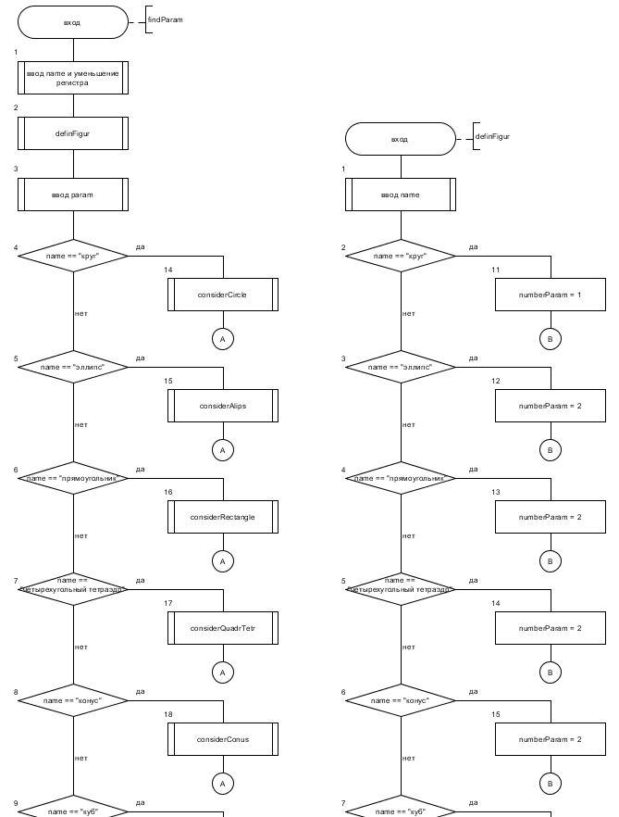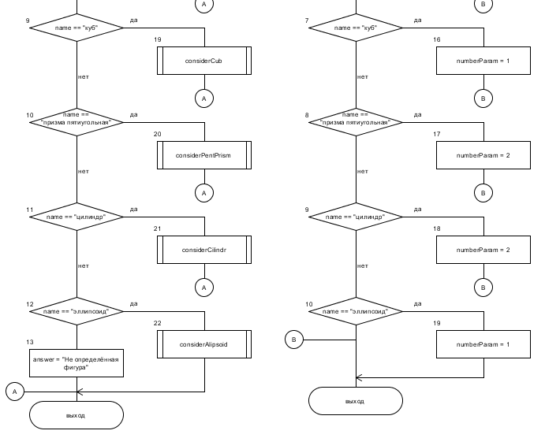

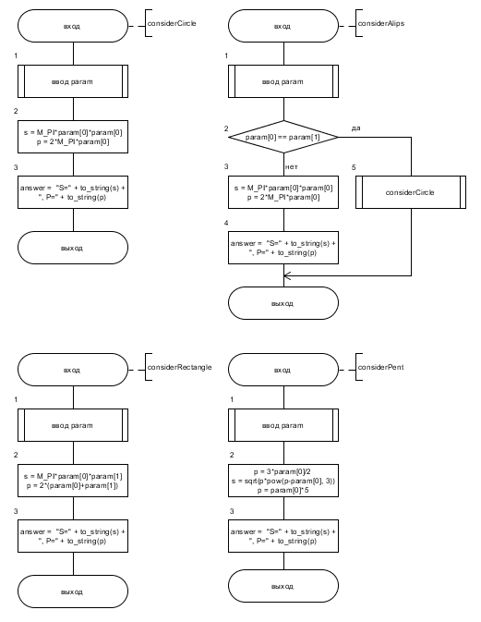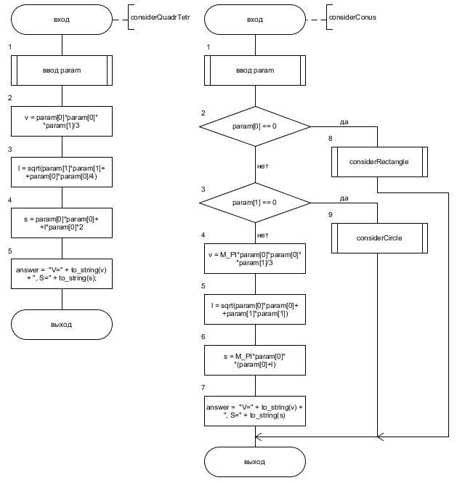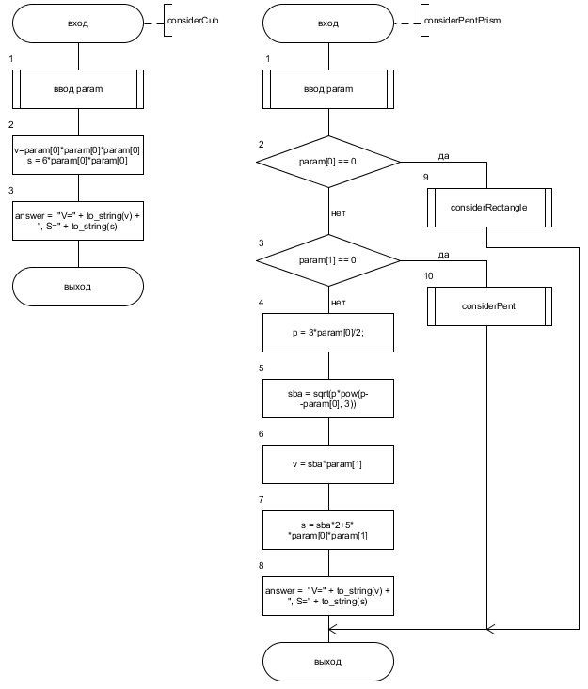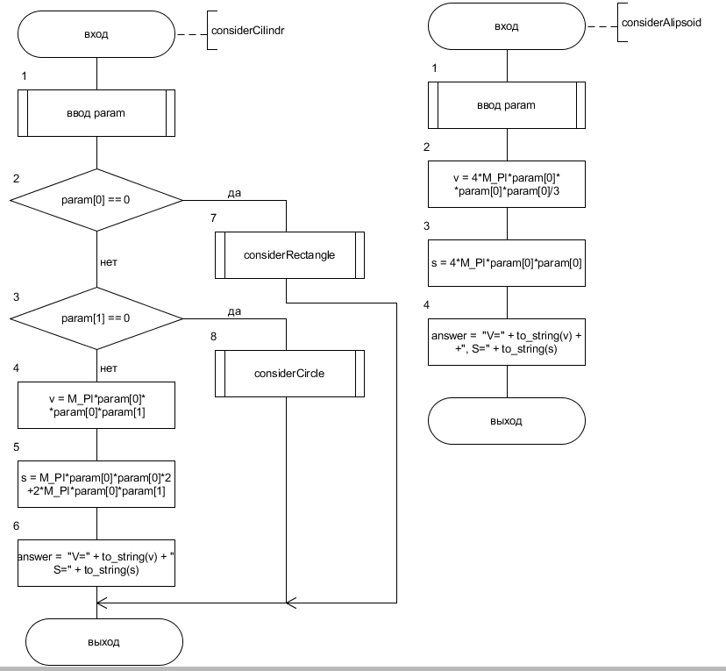

#define _USE_MATH_DEFINES

#include <iostream>

#include <cmath>

using namespace std;

int definFigur(string name)

{

int numberParam = 0;

// двухмерные фигуры

if(name == "круг")

{

numberParam = 1;

return numberParam;

}

if(name == "эллипс")

{

numberParam = 2;

return numberParam;

}

if(name == "прямоугольник")

{

numberParam = 2;

return numberParam;

}

// трёхмерные фигуры

if(name == "четырехугольный тетраэдр")

{

numberParam = 2;

return numberParam;

}

if(name == "конус")

{

numberParam = 2;

return numberParam;

}

if(name == "куб")

{

numberParam = 1;

return numberParam;

}

if(name == "призма пятиугольная")

{

numberParam = 2;

return numberParam;

}

if(name == "цилиндр")

{

numberParam = 2;

return numberParam;

}

if(name == "эллипсоид")

{

numberParam = 1;

return numberParam;

}

return numberParam;

}

string considerCircle(double param[3])

{

double s = M_PI*param[0]*param[0];

double p = 2*M_PI*param[0];

string answer = "S=" + to_string(s) + ", P=" + to_string(p);

return answer;

}

string considerAlips(double param[3])

{

if(param[0] == param[1]) return considerCircle(param);

double s = M_PI*param[0]*param[1];

double p = 4*(M_PI*param[0]*param[1]+param[0]-param[1])/(param[0]+param[1]);

string answer = "S=" + to_string(s) + ", P=" + to_string(p);

return answer;

}

string considerRectangle(double param[3])

{

double s = param[0]*param[1];

double p = 2*(param[0]+param[1]);

string answer = "S=" + to_string(s) + ", P=" + to_string(p);

return answer;

}

string considerPent(double param[3])

{

double p = 3*param[0]/2;

double s = sqrt(p*pow(p-param[0], 3));

p = param[0]*5;

string answer = "S=" + to_string(s) + ", P=" + to_string(p);

return answer;

}

string considerQuadrTetr(double param[3])

{

if(param[1] == 0) return considerRectangle(param);

double v = param[0]*param[0]*param[1]/3;

double l = sqrt(param[1]*param[1]+param[0]*param[0]/4);

double s = param[0]*param[0]+l*param[0]*2;

string answer = "V=" + to_string(v) + ", S=" + to_string(s);

return answer;

}

string considerConus(double param[3])

{

if(param[0] == 0) return considerRectangle(param);

if(param[1] == 0) return considerCircle(param);

double v = M_PI*param[0]*param[0]*param[1]/3;

double l = sqrt(param[0]*param[0]+param[1]*param[1]);

double s = M_PI*param[0]*(param[0]+l);

string answer = "V=" + to_string(v) + ", S=" + to_string(s);

return answer;

}

string considerCub(double param[3])

{

double v = param[0]*param[0]*param[0];

double s = 6*param[0]*param[0];

string answer = "V=" + to_string(v) + ", S=" + to_string(s);

return answer;

}

string considerPentPrism(double param[3])

{

if(param[0] == 0) return considerRectangle(param);

if(param[1] == 0) return considerPent(param);

double p = 3*param[0]/2;

double sba = sqrt(p*pow(p-param[0], 3));

double v = sba*param[1];

double s = sba*2+5*param[0]*param[1];

string answer = "V=" + to_string(v) + ", S=" + to_string(s);

return answer;

}

string considerCilindr(double param[3])

{

if(param[0] == 0) return considerRectangle(param);

if(param[1] == 0) return considerCircle(param);

double v = M_PI*param[0]*param[0]*param[1];

double s = M_PI*param[0]*param[0]*2+2*M_PI*param[0]*param[1];

string answer = "V=" + to_string(v) + ", S=" + to_string(s);

return answer;

}

string considerAlipsoid(double param[3])

{

double v = 4*M_PI*param[0]*param[0]*param[0]/3;

double s = 4*M_PI*param[0]*param[0];

string answer = "V=" + to_string(v) + ", S=" + to_string(s);

return answer;

}

string findParam(string name)

{

int numberParam = 0;

// уменьшаем регистр слова

for(int i = 0; i < name.size(); i++) name[i] = tolower(name[i]);

numberParam = definFigur(name);

if(numberParam == 0) return "Не определённая фигура";

double param[3] = {0};

for(int i = 0; i < numberParam; i++)

{

cin >> param[i];

if(param[i] < 0)

{

cout << "Передан отрицательный параметр, он взят по модулю" << "\n";

param[i] = -param[i];

}

}

if(name == "круг") return considerCircle(param);

if(name == "эллипс") return considerAlips(param);

if(name == "прямоугольник") return considerRectangle(param);

if(name == "четырехугольный тетраэдр") return considerQuadrTetr(param);

if(name == "конус") return considerConus(param);

if(name == "куб") return considerCub(param);

if(name == "призма пятиугольная") return considerPentPrism(param);

if(name == "цилиндр") return considerCilindr(param);

if(name == "эллипсоид") return considerAlipsoid(param);

return "Не определённая фигура";

}

int main()

{

string name, answer, a;

getline(cin, name);

answer = findParam(name);

cout << answer;

return 0;

}